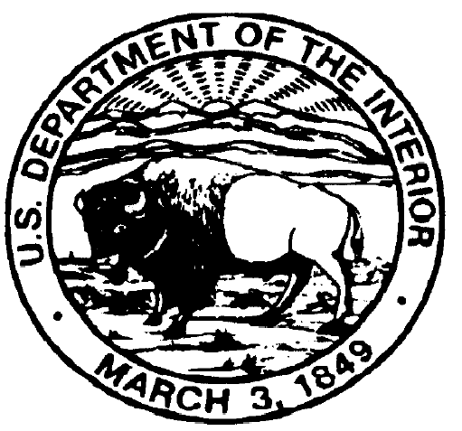  IN REPLY REFER TO: | United States Department of the Interior  NATIONAL PARK SERVICE  ASSATEAGUE ISLAND NATIONAL SEASHORE  7206 NATIONAL SEASHORE LANE BERLIN, MARYLAND 21811

OFF ROAD VEHICLE PERMIT REGISTRATION
PRINT Last Name |  | First name |  | Permit #
Name Vehicle Registered to (if different than above) |  |  |  | Month of Expiration |  | Employee
ADDRESS Street |  | City |  | State |  | Zip Code
Vehicle Year | Make | Model |  | Color
Vehicle Identification Number – VIN |  |  | License Plate Number |  | State

YOU ARE RESPONSIBLE FOR READING AND FOLLOWING ALL REGULATIONS LISTED BELOW.
- I have been given a copy of the Off Road Vehicle Permit regulations and I agree to comply with all the regulations and conditions.
- I understand that it is illegal to operate my vehicle on any sand dunes and/or vegetation except at posted crossovers.
- I agree to have the required equipment in my vehicle at all times while in the Off Road Vehicle Zone and to display said equipment upon request to officers of the National Park Service and Fish and Wildlife Service.
- I agree to permanently affix the permit to the driver’s side front bumper of the vehicle registered above and I understand that the permit is not transferable to another vehicle.
- I realize that if this vehicle is sold or is in an accident and I need a replacement permit, I must produce enough of the original permit to determine its complete number. I understand that without the original permit I will not be issued a replacement.
- I realize that violation of any regulation may result in fine and/or loss of the Off Road Vehicle Permit.
- Permits are valid for a full 12 months beginning with the month of purchase.

Signature ___________________________________________ Date ______________

